

**COMPUTER SCIENCE**

**Session: 2019-2020**

**BEACHWOOD SCHOOL**



Rik Biswas

class-xii

**Hospital Management**

***CONTENTS***

* **Acknowledgement**
* **Certificate**
* **Requirements**
* **Terminology and Imported Modules**
* **Hierarchy Of Tables**
* **My-SQL Tables**
* **My-SQL Commands**
* **Source Code**
* **Bibliography**

***Acknowledgement***

**I thank my Computer Science teacher Mr. Suvabrata Saha for guidance and support. I also thank my Principal Mr. Amit Sinha for his co ordination. I would also like to thank my parents and my friends for encouraging me during the course of this project. Finally I would like to thank CBSE for giving me this opportunity to undertake this project.**

***Certificate***

**This is to certify that Rik Biswas of class twelve, Beachwood School, Durgapur has successfully completed his project in computer practical as prescribed by CBSE in the year**

**2019-2020.**

**Date :-15.11.2019**

**Signature of Internal Signature of External**

**Examiner Examiner**

**__________________ __________________**

**Requirements**

* **Hardware Required**
* **Printer, to print the required documents of the project**
* **Compact Drive: 1 GB**
* **Processor : Intel Core I3**
* **Ram : 8 GB**
* **Hardisk : MB.**
* **software Required**
* **Operating system : Windows 7 Ultimate**
* **Python 3.6.5 , for execution of program and**

Terminology And Imported Modules

For the completion of this we have used Python 2.7 version as it is user friendly and commonly supported among all the machines.

To store the information under a Database Management System we have used MySql Queries and to create the tables and insert the initial data we have used MySql Command Line.

As a program based database management code we have used Python-Mysql Connectivity to dynamically insert, alter and read data from the database..

To ensure proper user interaction and provide a user friendly environment we have implemented PiP Module to python and imported a special Library named “PrettyTable” which functons to Arrange the tabular data under a well structured table and not a unicode implemented list. The Imported modules and and File attachments are attached as a soft copy in a CD with the provided Channel file.

Hierarchy of Tables

MySql Tables

1.Employee

|  |  |  |  |
| --- | --- | --- | --- |
| **Attribute** | **Description** | **Data Type** | **Condition** |
| EID | Employee ID | Varchar(3) | Primary Key |
| Name | Employee Name | Varchar(30) |  |
| Sex | Gender Of Employee | Varchar(1) |  |
| Department | Job Of Employee | Varchar(30) |  |

2.Salary

|  |  |  |  |
| --- | --- | --- | --- |
| **Attribute** | **Description** | **Data Type** | **Condition** |
| EID | Employee ID | Varchar(3) | Primary Key |
| Salary | Income Of Employee | Varchar(30) |  |
| Pay_Frequency | Time Of Payment | Varchar(30) |  |

3.Doctor

|  |  |  |  |
| --- | --- | --- | --- |
| **Attribute** | **Description** | **Data Type** | **Condition** |
| DID | Doctor ID | Varchar(3) | Primary Key |
| Name | Doctor’s Name | Varchar(30) |  |
| Specialist | Category Of Doctor | Varchar(30) |  |
| Experiance | Work Experiance | Integer |  |
| Charge | Doctor Fees | Integer |  |
| Timing | Time Of Availibility | Varchar(20) |  |

4.Registration

|  |  |  |  |
| --- | --- | --- | --- |
| **Attribute** | **Description** | **Data Type** | **Condition** |
| PID | Patient ID | Varchar(3) | Primary Key |
| Name | Patient’s Name | Varchar(30) |  |
| Age | Patient’s Age | Varchar(1) |  |
| Gender | Patient’s Gender | Varchar(30) |  |
| RegDate | Date Of Registration | Timestamp |  |
| PhNumber | Contact Number | Varchar(13) |  |

5.Appointment

|  |  |  |  |
| --- | --- | --- | --- |
| **Attribute** | **Description** | **Data Type** | **Condition** |
| PID | Patient ID | Varchar(3) | Primary Key |
| DID | ID of the consulting Doctor | Varchar(3) | Foreign Key(Doctor) |
| ApptDate | Date Of Appointment | Timestamp |  |

Create Table :

MySQL Commands

1.Create Table Employee

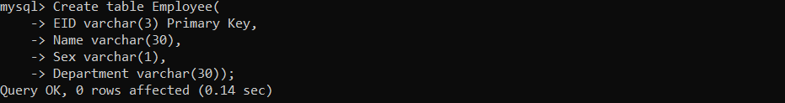

2.Create Table Salary

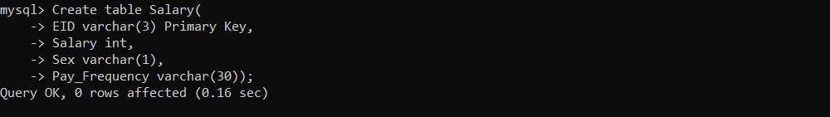

3.Create Table Doctor

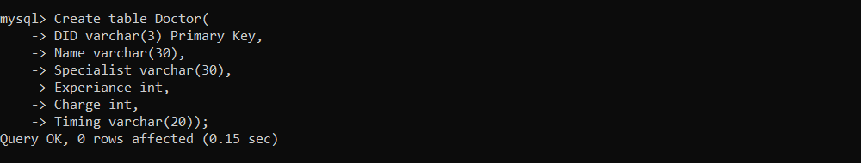

4.Create Table Registration

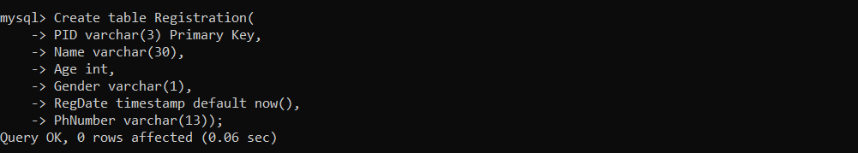

5.Create Table Appointment

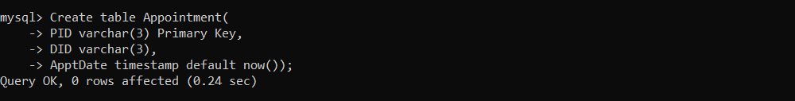

**Insert into Table:**

1. Doctor:-

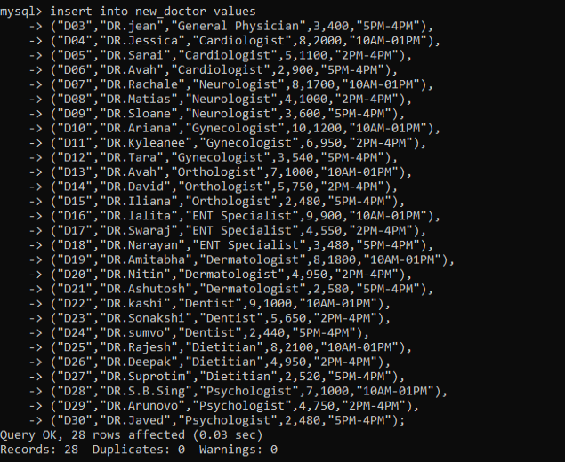

2. Employee:-

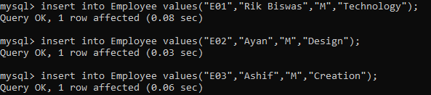

**\*Insertion of data into other tables is made through the Python Program by user choice**

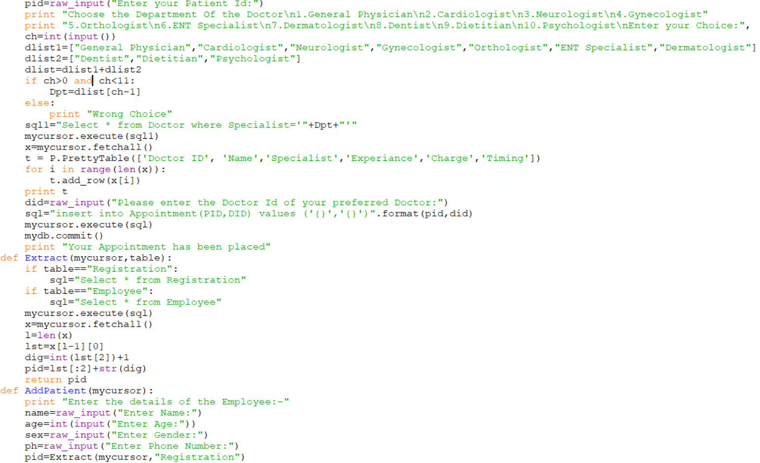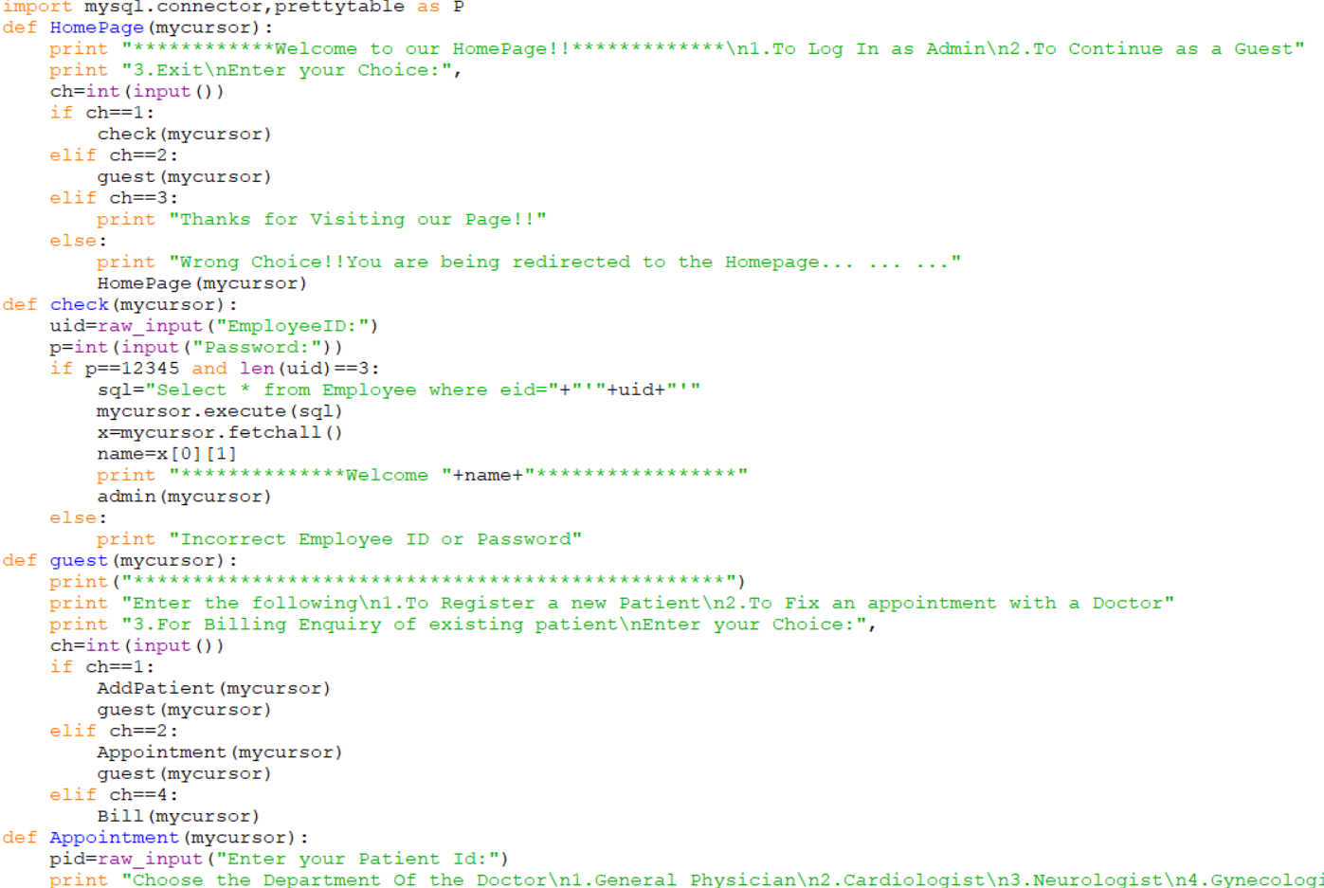Source-Code

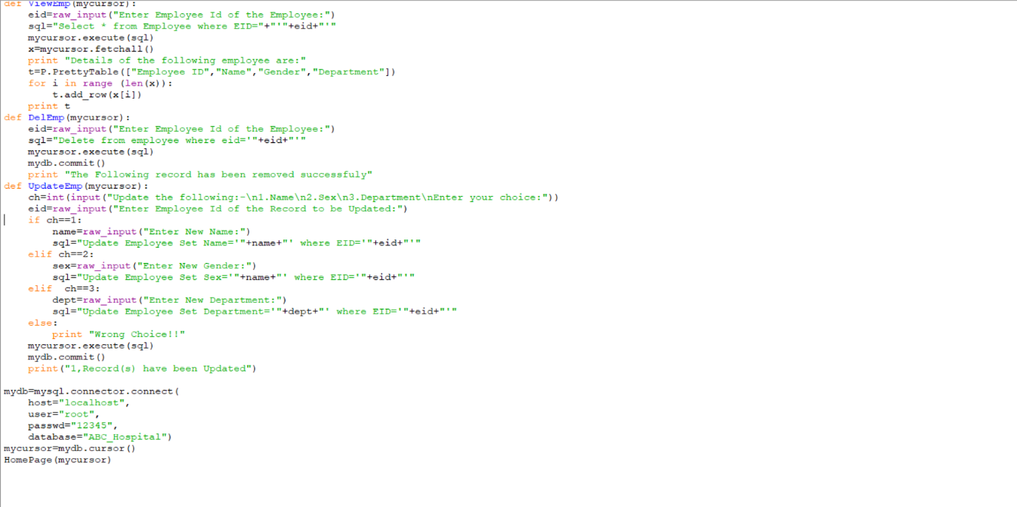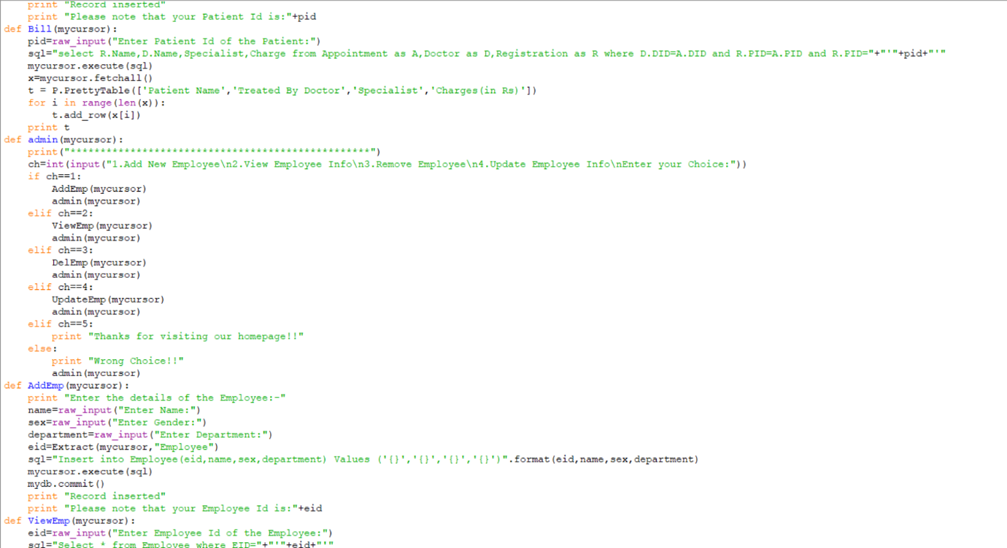

Bibliography

For the completion of this project, I have taken assistance from the following websites:-

